Name: Prachi Mahavir Patil.

Roll No. : B27

PRN: 2122000442

___________________________________________________________________________ Experiment No. 8

**Create and manage NoSQL Databases with Cassandra**

**___________________________________________________________________________**

Problem Statement :

1. Create keyspace : employee

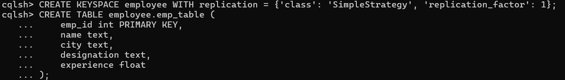

1. Create : emp_table (

... emp_id int,

... name text,

... city text,

... designation text,

... experience float,

... primary key(emp_id));



1. Perform following operations on created table:

a. Insert rows

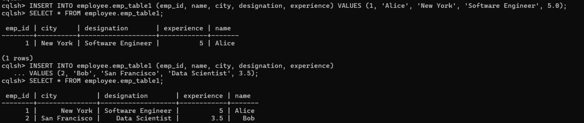 b. Update rows

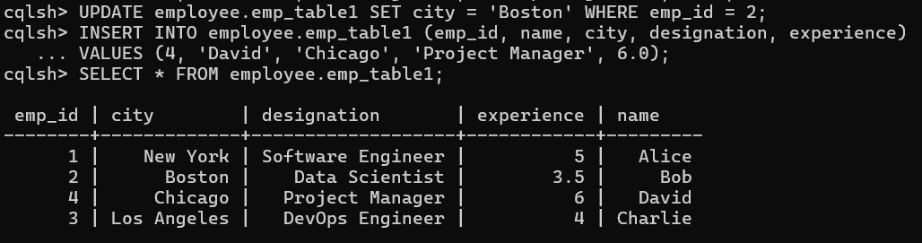

* + 1. Update rows with upsert



* + 1. Retrieve data from table

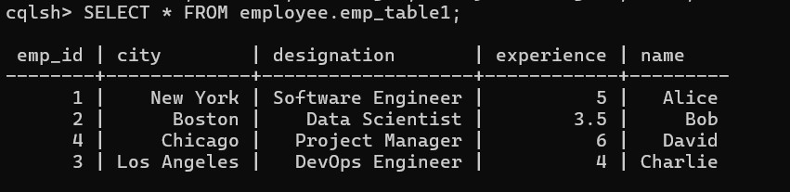

* + 1. Alter table add columns ((email set<text>, expertise list<text>, prev_jobs map<text, int>



* + 1. Insert new rows

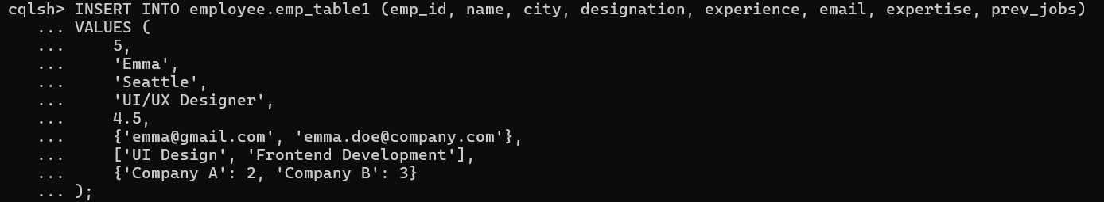

* + 1. Delete rows and values



1. create table product(

... id uuid,

... name text,

... price float,

... quan int,

... primary key(id));

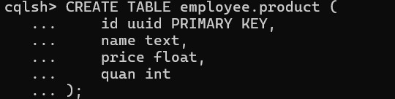

1. Perform following operations on created table:
   1. Insert rows

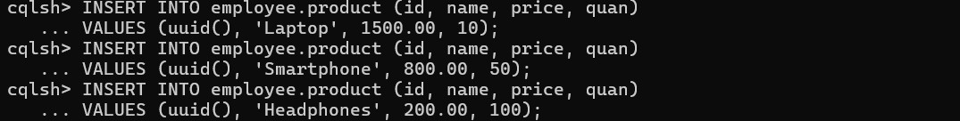

* 1. Alter table product add (inv_date timestamp, available boolean);

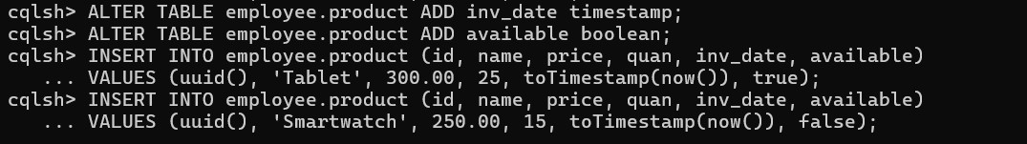

* 1. Insert new rows

